Lab 3
Ayesha Gohar
23i-3030
Task 1:
Initiate workflow execution upon receipt of a new email in the Gmail inbox.
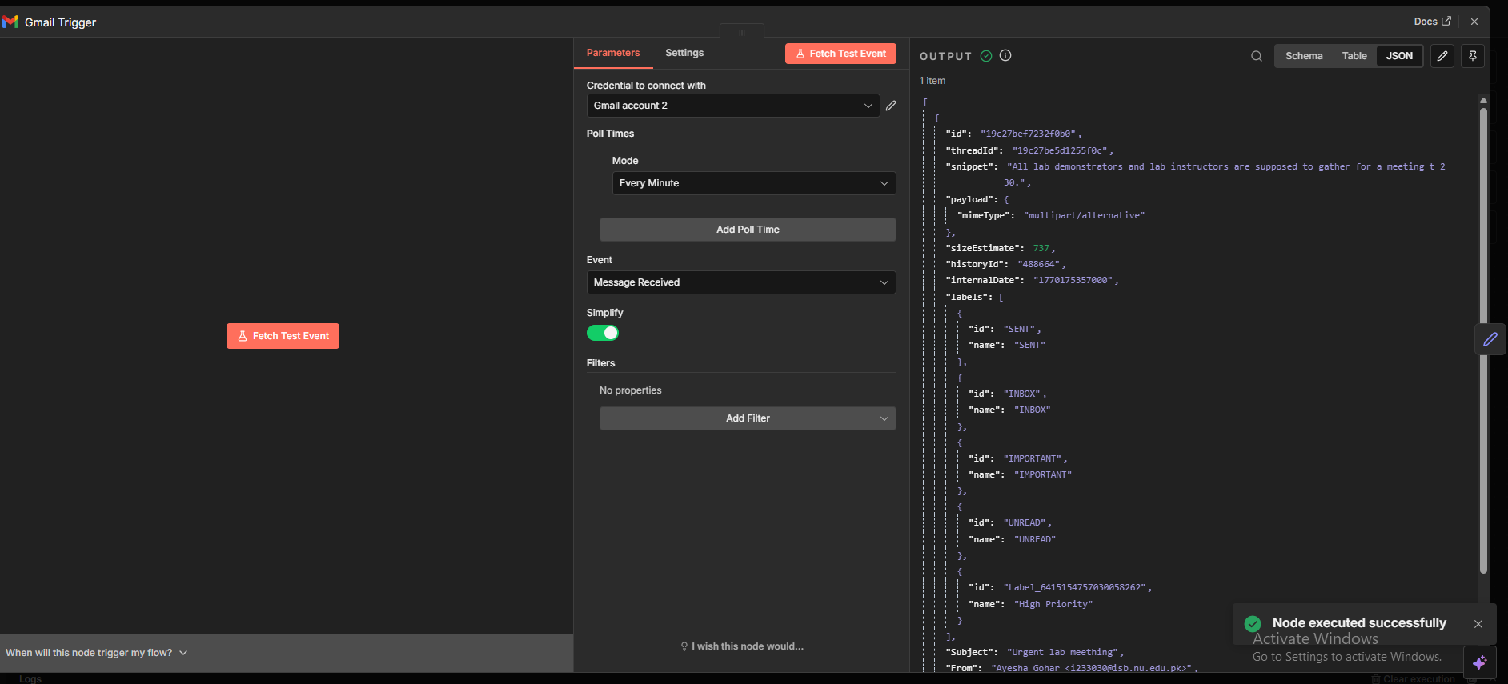
Extract and retain only semantically relevant fields for downstream NLP processing:
- Email body
- Sender address
- Subject line

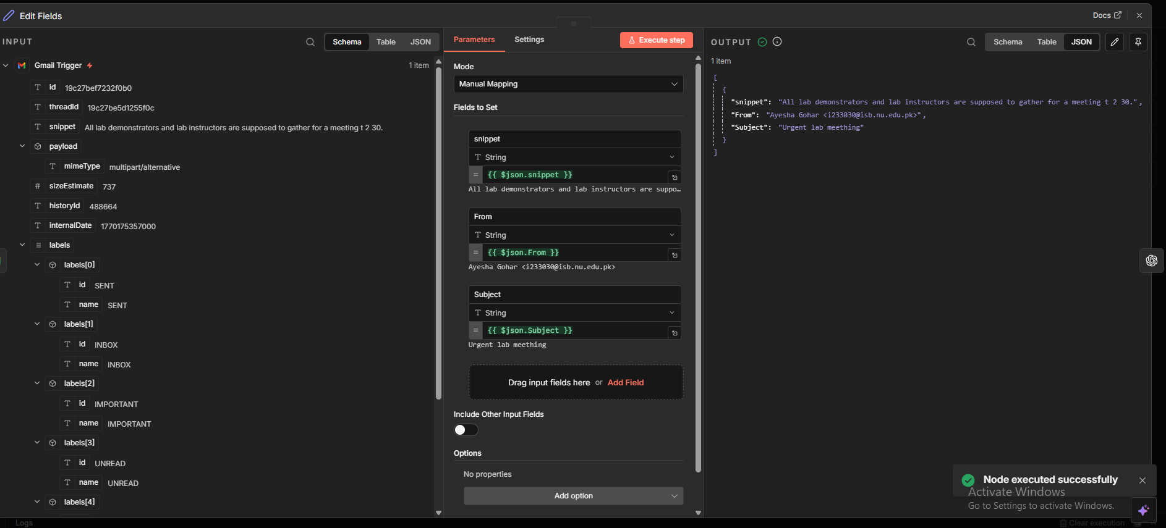
Apply a large language model to infer the semantic intent of the email as Lab_Query, Departmental_Meeting or Ignored.
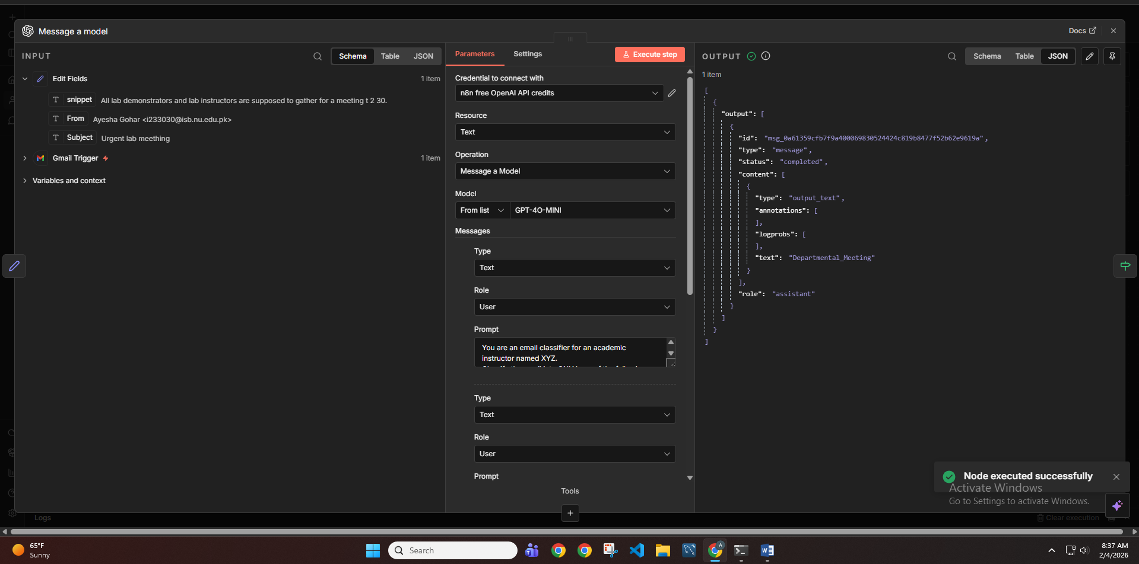
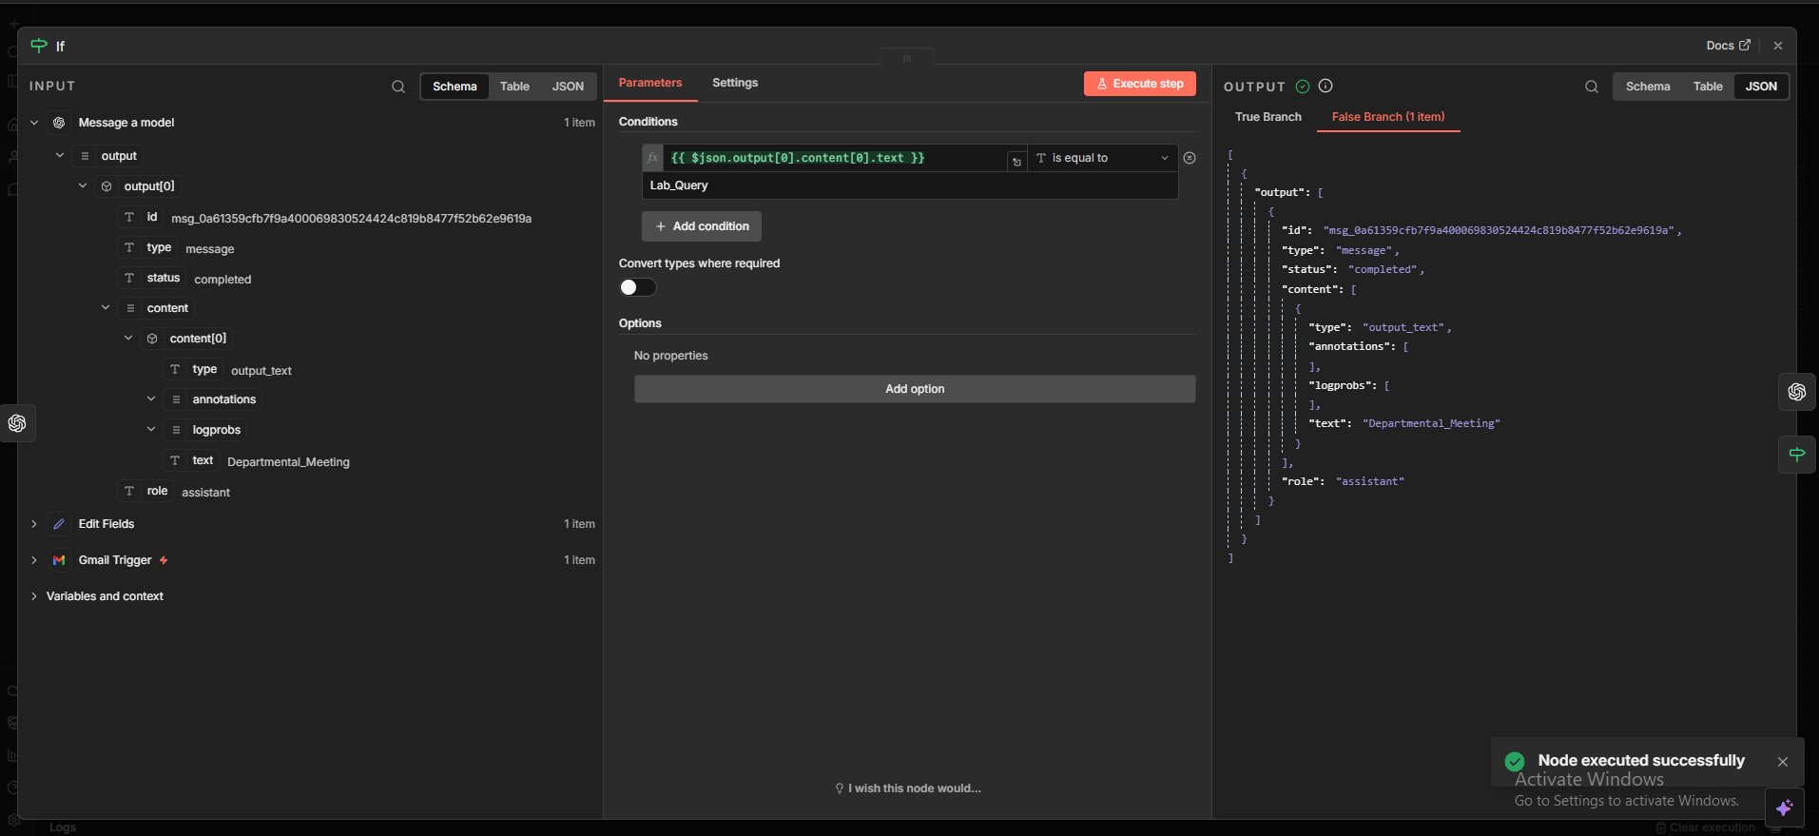
Branch A:
Invoke an OpenAI node to generate a professionally worded draft email requesting missing
academic identifiers and issue clarification.
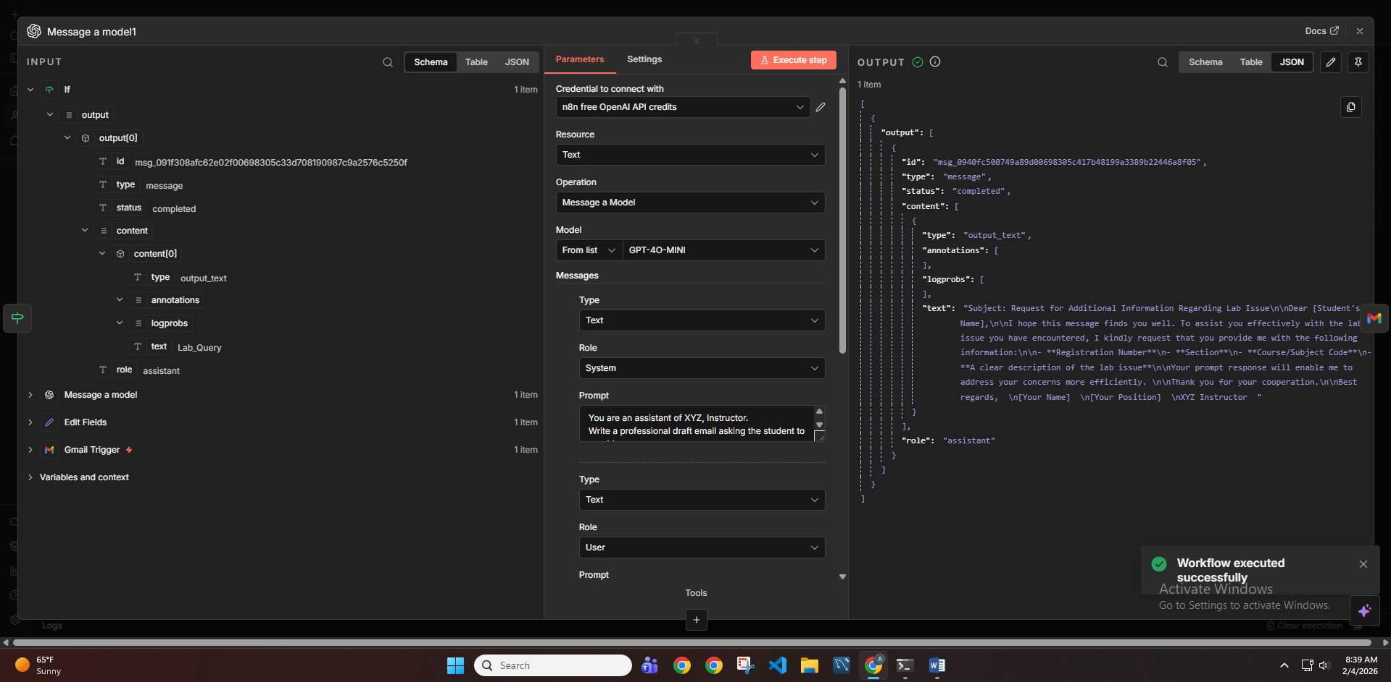

Create a draft from Generated Response.
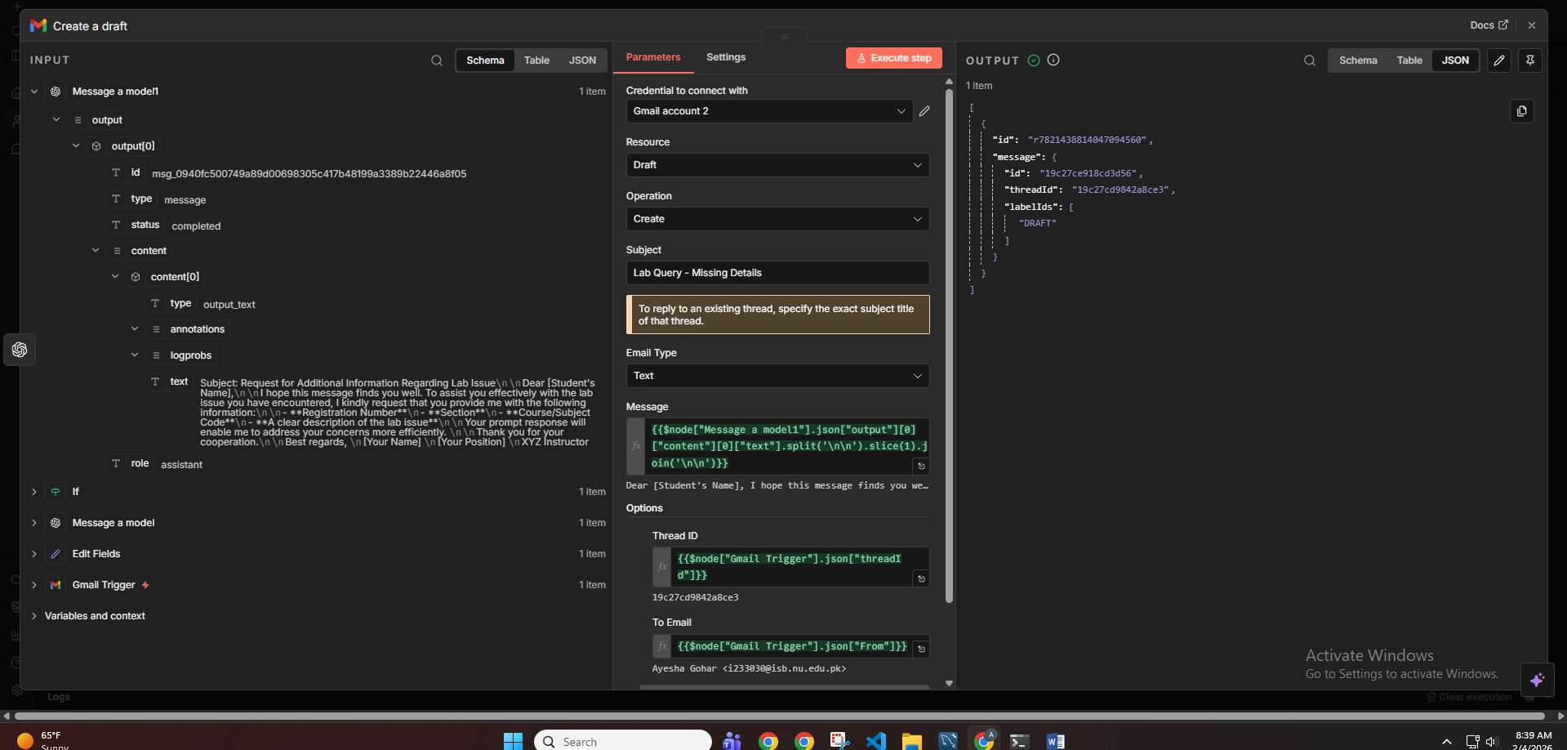
Branch B:
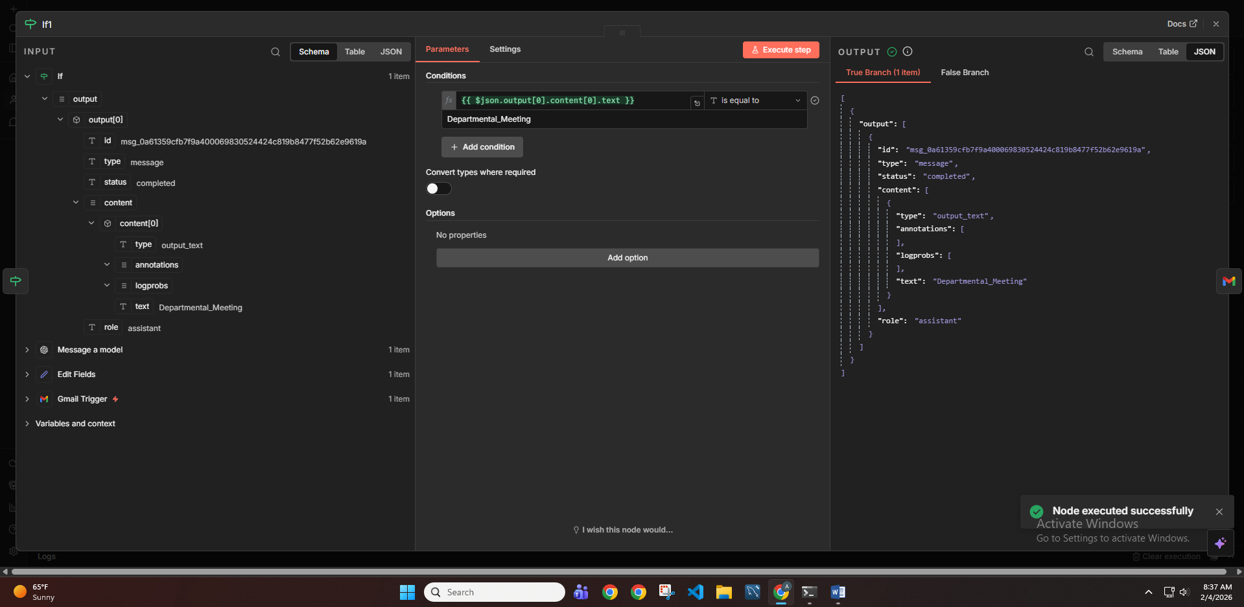

If the email pertains to departmental coordination or urgent academic matters then apply Gmail label: High Priority
